1. In login page, use regular expression to check whether the user’s inputs are valid or not. The input should start with character and end with number. The length of the input should be longer than 6 digits. If the input is invalid, the page will show warning message.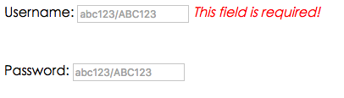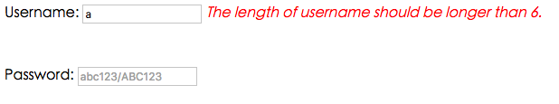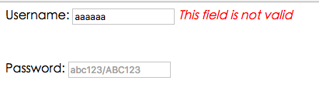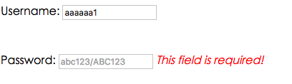
2. Verify login, check whether the username and password are matched with the information in database. It will also check the authority of the user from the database and direct to different pages according to the user’s authority. For example, if the authority of a user is manager, then the page will direct to hotel managing page. Otherwise it will direct to hotel booking page.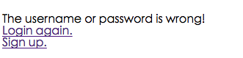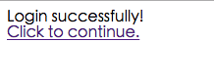螢幕快照%202016-11-28%20下午10.54.20.png
3. In sign up page, users can sign up for this web app. It will check the format of user’s input just like the login page. What’s more, AJAX is used to check whether the username that users input has been used or not. While users are typing in the Username input box, a function call checkExist() using AJAX will check whether the current input have been in the database or not, and return a response to inform users frequently.



d. In the hotel managing page, the manager can modify the price of a room type in a hotel. Manager can firstly select the hotel he wants to modify. AJAX is used in this page. After the user select a hotel, AJAX will help to find the whole room types in the selected hotel. Then user can choose the room type that he wants to modify. After selecting, the current price will show on the screen with an input text box that allows users to update the price. All information in this page is generated from the database.

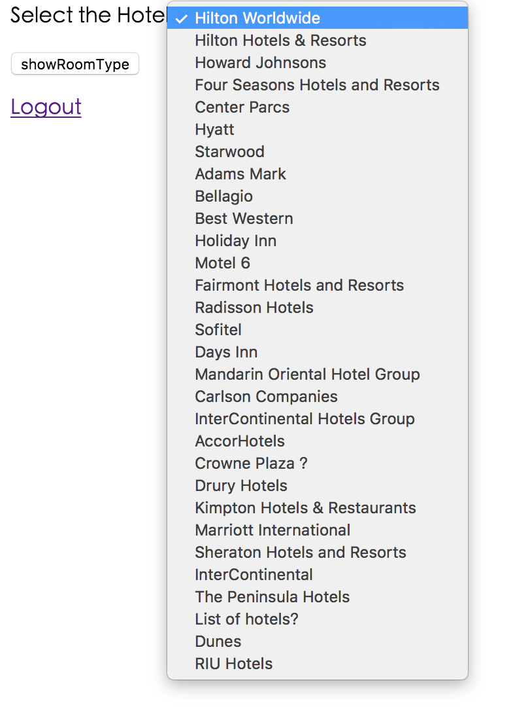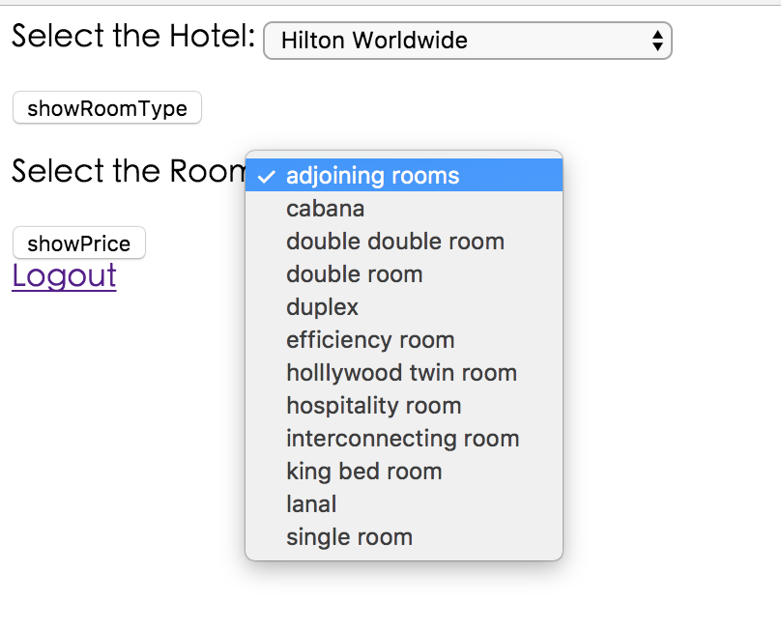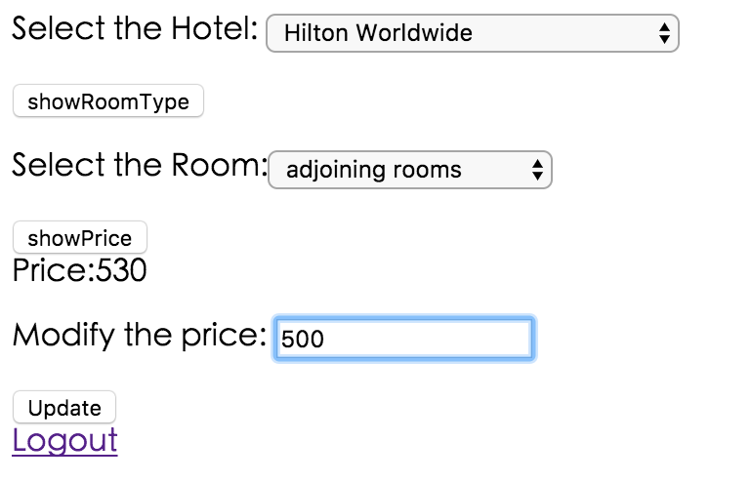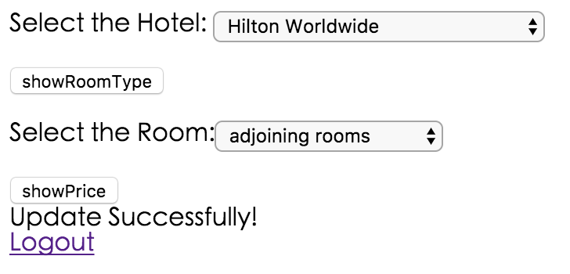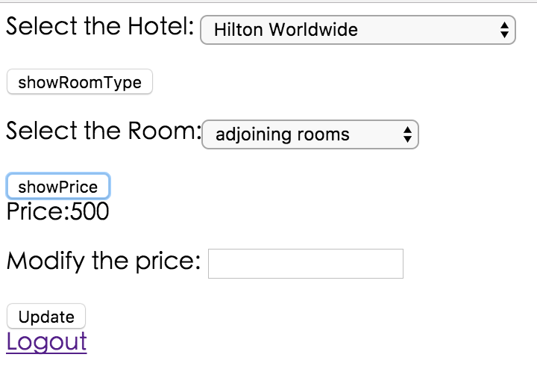

e. After user successfully login, a map using Google Map API will show on the screen with various icons that stand for different hotels. The icons also have different colors: red, green, yellow. The color means the number of the remaining room in that hotel. Red means crowded, yellow means normal and green means empty. By default, the remaining room information is set to the current day. 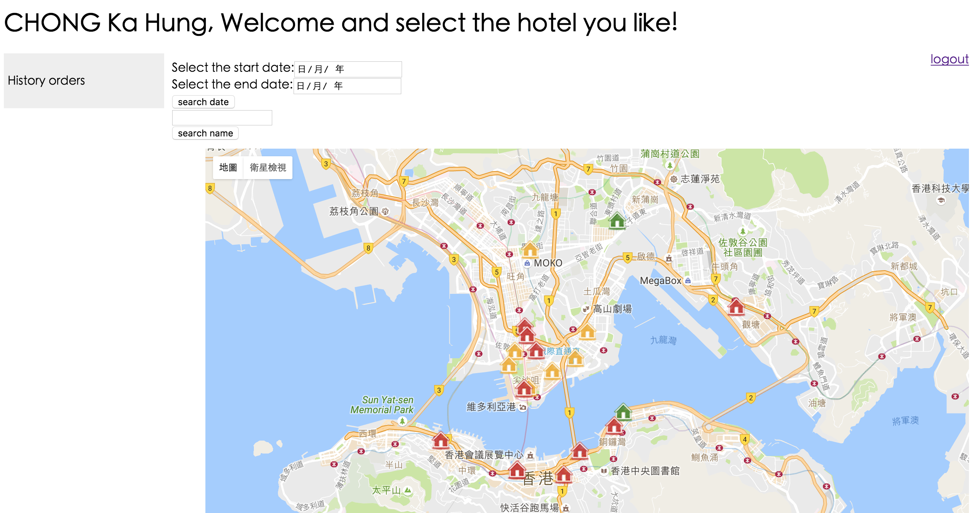

User can select start date and end date to see different results of remaining room in the selected period. And AJAX helps to generate the result from database to the screen.

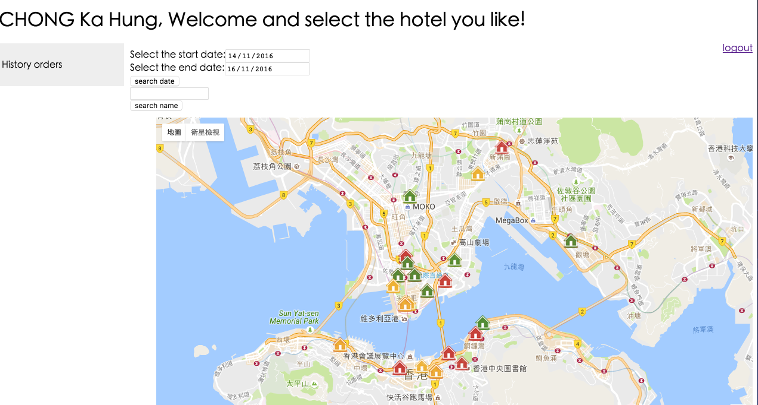

User can also search the hotel by name. A HTML 5 data list are used to provide search suggestions. The content of the data list options comes from the database. After searching, the location of the result will display on the screen. This function is also done by the AJAX.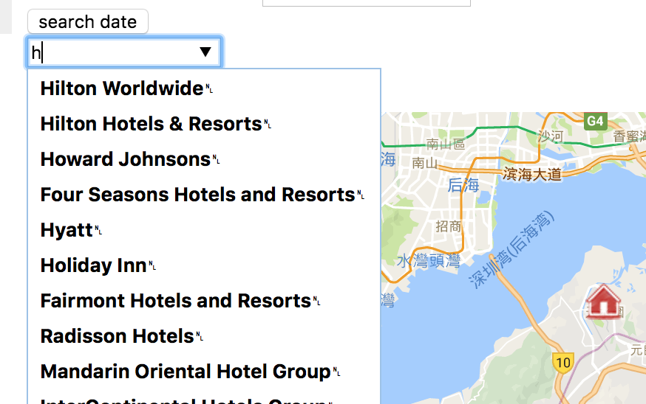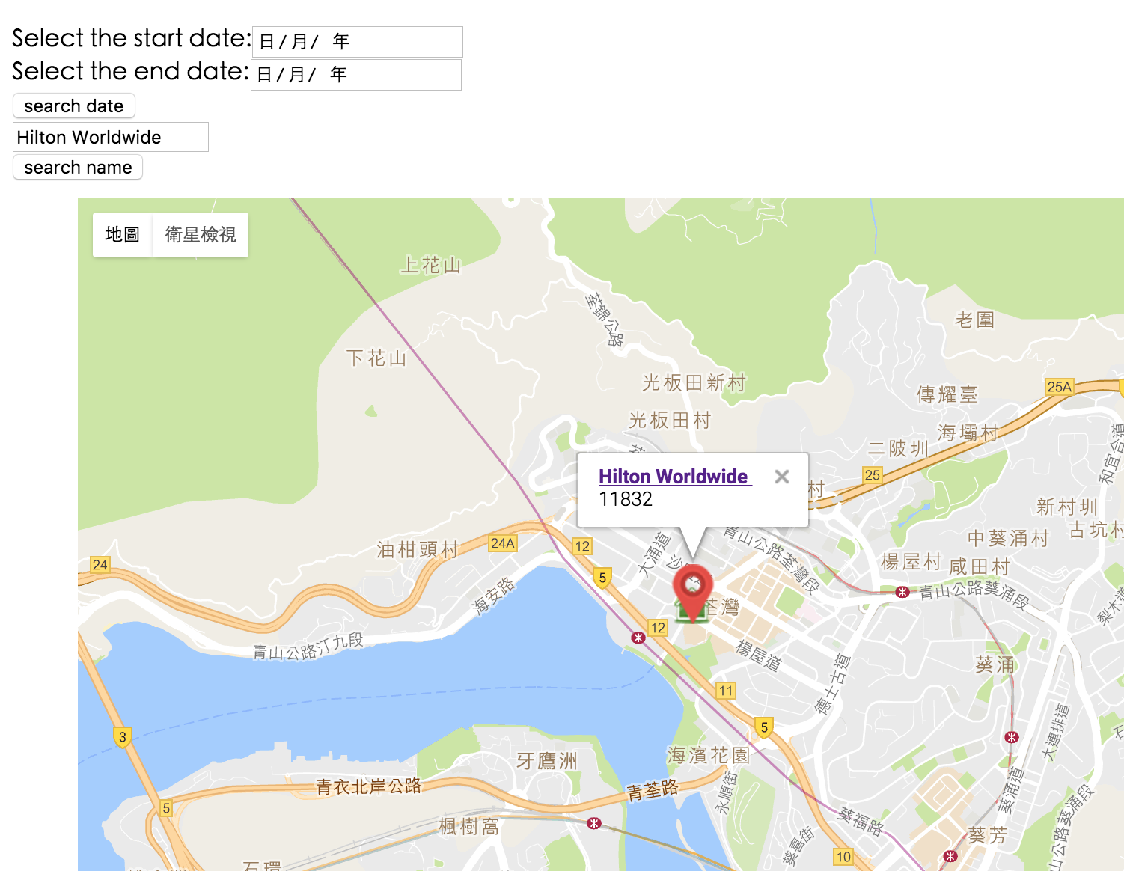

The showLabel function shown below is used to show labels on the map.

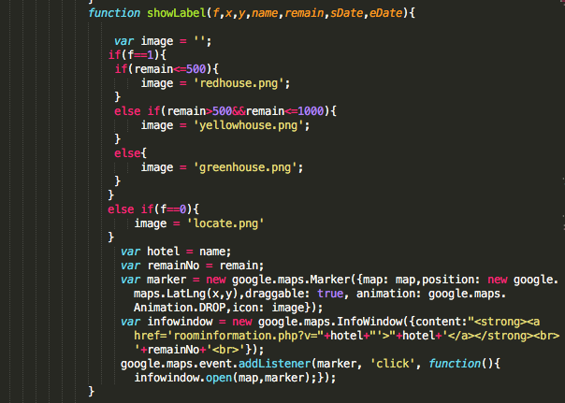

f. In the map.html page, there is a History orders div. When the mouse is on the History order area, the history orders of the user from database will be shown with the help of AJAX.

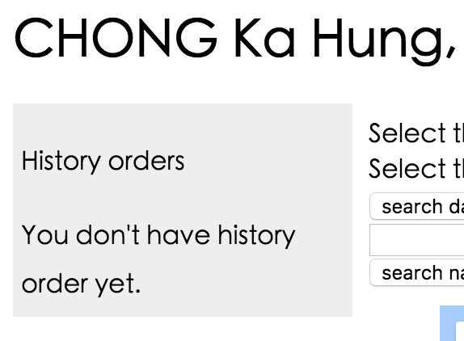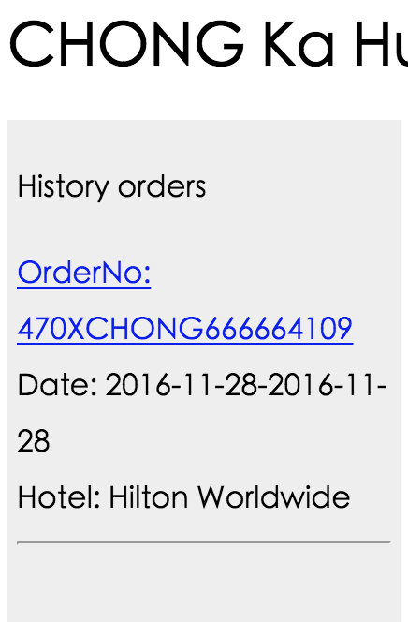

g. When user click the OrderNo in the History orders, a page shows the detail of the order will be shown. It allow user to leave comment on this order.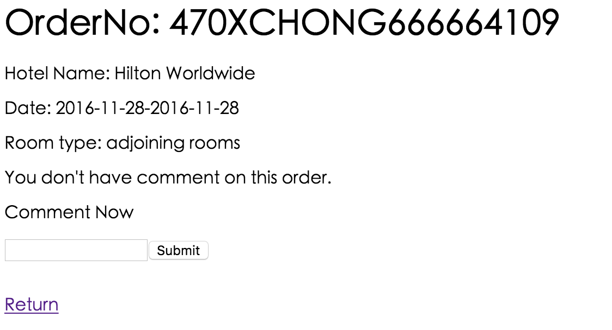

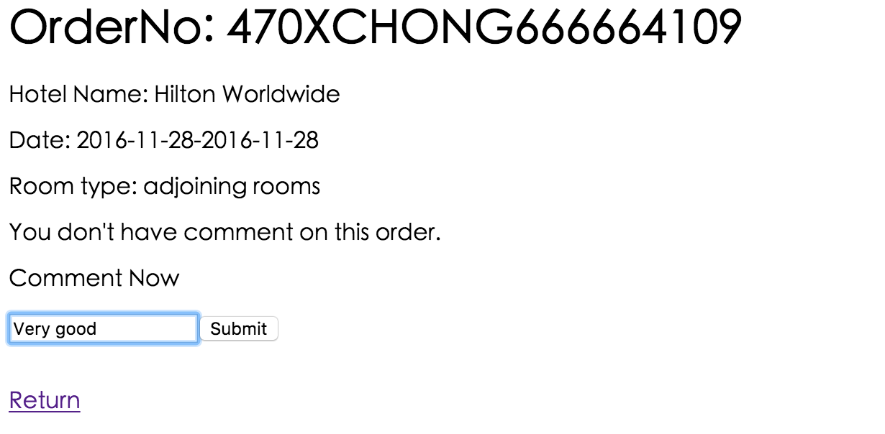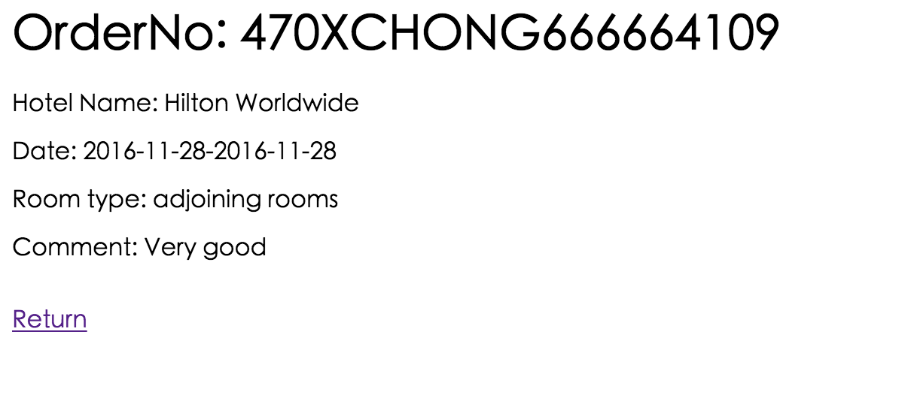

User account

Sign up

Wrong pwd

Manager account

manager.php

newBooking.php

Signup.php

map.html

historyOrderPage.php

login

Signup.html

roomInformation.php

Comment.php

verifyLogin.php

Login.html